ASSIGNMENT – I DOMAIN: IOT

TITLE: SMART HOME

Team Members-3: DOLPHY LESARE Register Number: 422019106002 Schematic (Circuit Diagram)

SMART Home Circuit Connection:

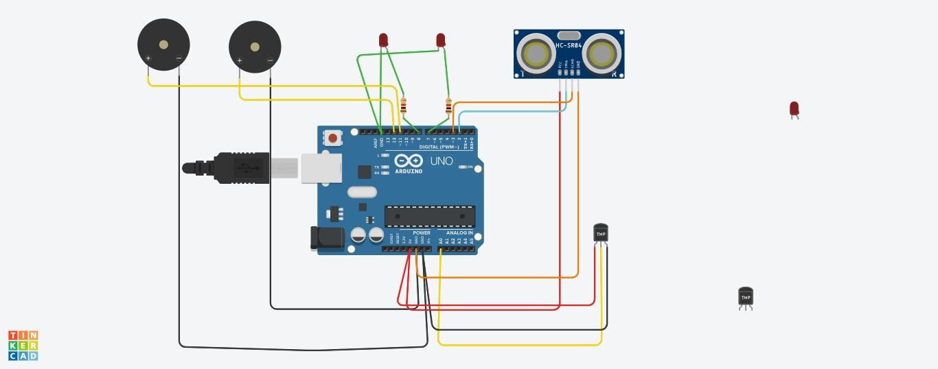

Components Used:

i) 2 Piezo Buzzer ii)Temperature Sensor iii)Ultrasonic Sensor

iv) LED -2 v)Resistor-2

**Code:**

int t=2; int e=3;

void setup()

{

Serial.begin(9600); pinMode(t,OUTPUT); pinMode(e,INPUT); pinMode(12,OUTPUT);

}

void loop()

{

//ultrasonic sensor digitalWrite(t,LOW); digitalWrite(t,HIGH); delayMicroseconds(10); digitalWrite(t,LOW);

float dur=pulseIn(e,HIGH); float dis=(dur*0.0343)/2; Serial.print("Distance is: "); Serial.println(dis);

//LED ON

if(dis>=100)//(in terms of centimeter)

{

digitalWrite(8,HIGH); digitalWrite(7,HIGH);

}

//Buzzer For ultrasonic Sensor if(dis>=100)

{

for(int i=0; i<=30000; i=i+10)

{

tone(12,i); delay(1000); noTone(12); delay(1000);

}

}

//Temperate Sensor double a= analogRead(A0);

double t=(((a/1024)*5)-0.5)*100; Serial.print("Temp Value: "); Serial.println(t);

delay(1000);

//LED ON

if(t>=100)//(in terms of celsius)

{

digitalWrite(8,HIGH); digitalWrite(7,HIGH);

}

/Buzzer for Temperature Sensor if(t>=100)

{

for(int i=0; i<=30000; i=i+10)

{

tone(12,i); delay(1000); noTone(12); delay(1000);

}

}

//LED OFF

if(t<100)

{

digitalWrite(8,LOW); digitalWrite(7,LOW);

}

}

**TINKERCAD LINK:**

https:[//www.tinkercad.com/things/04FPijtpzQx-sizzling-](http://www.tinkercad.com/things/04FPijtpzQx-sizzling-) wluff/editel?sharecode=crzWiaOKQ60gifycKs5plLr2No2f9OiiS32dXeYGf74